|  |
| --- |
| Circle Language Spec: Commands |

## Inactive Clauses in a Command Call in a Diagram

This article demonstrates a situation of command objects.

This article illustrates how inactive clauses in a command call look in a diagram.

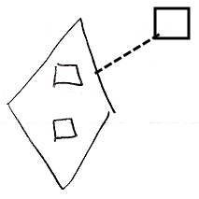

The diamond shape is a command call. The command definition of the command call is pointed out by the dashed line, pointing at the square on the right, which is the command definition. The diamond contains two squares, that do not redirect. Those are the inactive clauses inside the command call. They are clauses, because they are situated inside a command symbol and they do not redirect their target.